Virtual Environment for Visualizing Vocal Features
and Its Application to Voice Training

Yoya Nakashima, Tsuyoshi Moriyama

Tokyo Polytechnic University
1583 Iiyama, Atsugi,
Kanagawa, 243-0297 Japan
moriyama@mega.t-kougei.ac.jp

Abstract

It is difficult for us to check the efficacy of voice training by listening to our own voice because we cannot hear only the air transmitting component of the uttered voice without the one transmitted through bones. It is the reason why we have to ask others to evaluate our own voice on our behalves. Also, we cannot see sounds. It gives a rationale that computer systems capable of transforming invisible voice quality into visible form such as scores and graphs are helpful. We have investigated a computer assisted voice training system that analyzes voice for evaluating acoustic characteristics and visualizes them so that the speaker can receive a kind of feedback for better utterance in future. Since voice quality is often related to colors (e.g., yellow voice by young females), we consider transforming voice quality into color. Firstly, we divide an input utterance into phonemes and secondly analyze the acoustic characteristics according to the phoneme class, i.e., vowel class, plosive class, fricative class, and silence class. For visualizing the vocal quality, we use augmented reality so that speakers can get more intuitive idea of how his/her voice sounds [7] . We also examined virtual reality that was supposed to feedback the speaker of his or her voice more straightforwardly by reflecting the acoustic characteristics in the surrounding virtual environment.

Keywords-speech analysis, voice training, articulation styles, acoustic features, visualization, virtual reality

I. Introduction

Not only those who are engaged with such kind of profession that use their voice in their work such as singers and actors but also those who work in call centers or even in normal companies pay more attention to voice training these days in order for them to give better presentations. Voice training is also regarded as an effective way of keeping elderly people active in aging society.
A typical way of voice training requires the trainees to ask trainers to listen to their voice, but it is costly and also not ideal in the sense that trainees should expose their voice to others against hesitation. If they can train their own voice by their own, it should be better. Recent smart phones provide an application software that makes the dream come true. Yet, they only show the voice evaluation by numbers so that users cannot gather which part of their voice has what kind of problem. More intuitive way is needed.
We have been investigated such a system that is capable of visualizing acoustic characteristics of voice for giving the feedback to the speaker. Here we use color as an effective indicator for the visual feedback together with virtual reality device. The experimental results are reported in this paper.

II. Suitable acoustic parameters for voice evaluation

A. Classification of phonemes based on the articulation

Phonemes used in languages consist of vowels and consonants. They sound differently due to both the position of articulation and the way of making sounds. Vowels accompany excitation of vocal tract, and the size of mouth opening and the position of tongue determines the kind (e.g., /a/ is wide in mouth opening and backward in the position of tongue, whereas /i/ is narrow and forward for each). Consonants are generally categorized into two groups “plosives” and “fricatives” as shown in Table 1.
Ideal vowels have stable volume and pitch (vocal height) across utterance because that indicates the muscles for exhalation are used stably and also those for controlling vocal tract are relaxed. “Jitter” (the standard deviation of pitch frequencies in short period of time) and “shimmer” (the standard deviation of power values in short period of time) are supposed to be effective indicators for evaluating it [5] .
Fricative consonants should be evaluated by such acoustic features that can indicate how the speaker continuously and strongly makes the exhalation friction at the articulation point. We assumed the length of the fricative period and the dynamic range of the power during the period would be feasible.
TABLE I
CONSONANTS.

 | phonemes
 | plosives | affricates | fricatives | nasals | liquid and semivowels
lip | /p/  /b/ |  |  | /m/ | /w/
teeth | /t/  /d/ | /ts/  /dz/ | /s/  /z/ | /n/
palate | /k/  /g/ |  | /h/ |  | /r/

Plosive consonants should be evaluated by such acoustic features that can indicate how well the speaker stop the exhalation at the articulation point. We assumed that the length of the silent period that was created by stopping exhalation would be feasible.
1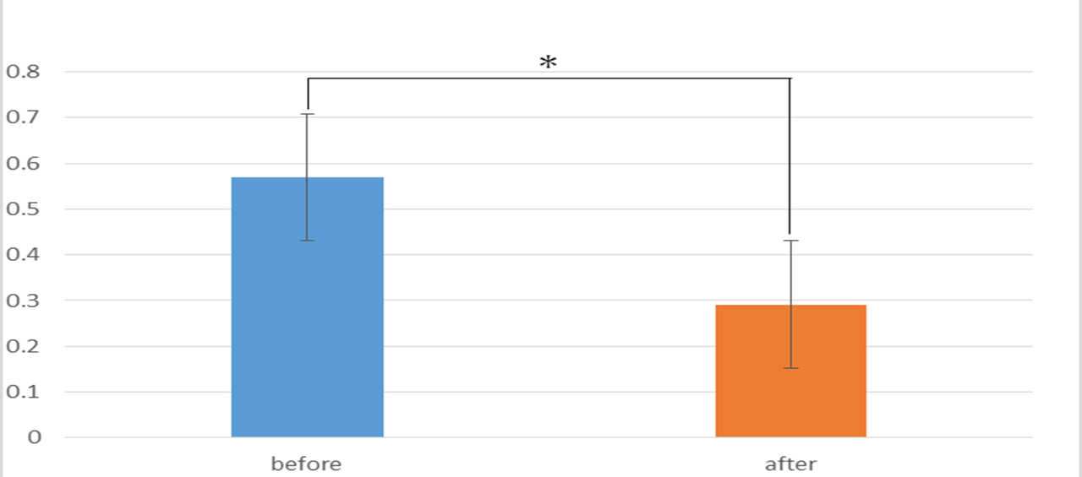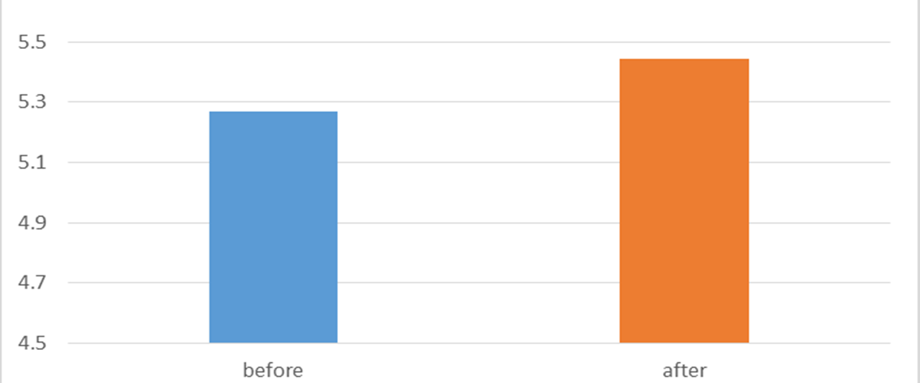
(a) jitter (b) shimmer

Fig. 1. Comparison of acoustic feature for vowel class between before and after voice training.
B. Validation of Acoustic Features for Speech Evaluation

We asked ten subjects to take a voice training course whose trainer was well experienced and calculated the acoustic parameters explained above. The following results show the comparison between those before (blue) and after (orange) the training with respect to each four class. Fig.1 shows the result for the vowel class. Fig.2 shows that for the fricative class (each one of four pairs corresponds to the result for the first /s/ from each different word /sazanami/, /samidare/, /sampo/, and their average.) Fig.3 shows the result for the plosive class (each one of four pairs corresponds to the result for the first /t/ from each different word /taitei/, /tai-iku/, /taikutsu/, and their average.) T-test calculated for the difference between before and after the training course demonstrated that "jitter" for the vowel class, the dynamic range of power for the fricative class, and the length of silent period of time for the plosive class significantly differed between before and after training.
In other words, these three acoustic parameters are feasible for visualizing the effect of voice training.

III. Experiments

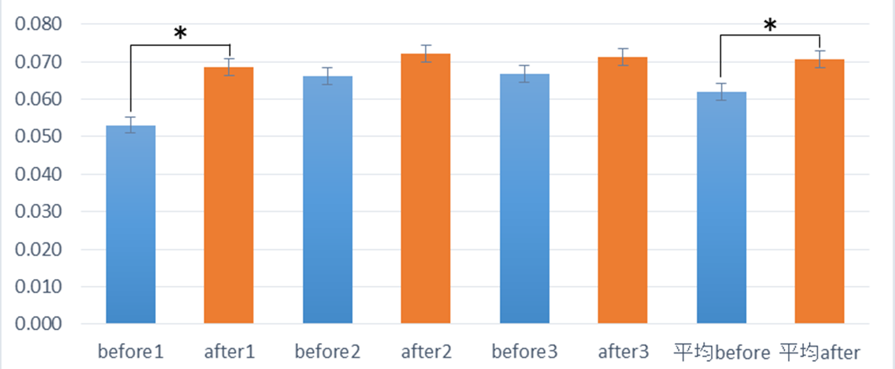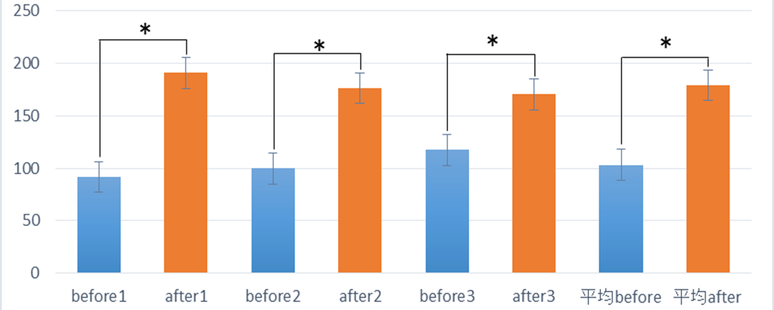
(a) length of silance (b) dynamic rage of power

Fig. 2. Comparison of acoustic feature for fricative class between before and after voice training.

We applied the acoustic parameters that have been confirmed to be useful in visualizing the effect of voice training in Section II to actual training process using a virtual environment.

A. Virtual Environment

Virtual environment defines computer-generated immersive panoramic view that tracks the change of user's head motion and changes the view according to it. We used Oculus Rift for the viewer [8] .
Here we consider reflecting acoustic variation of user's voice in the virtual environment, i.e., we calculate the acoustic parameters mentioned above and changes the virtual view (color) depending on the parameter values.
Our expectation is that the surrounding view of the user that reflects his or her behavior (vocal utterance here) in real time should give the more direct feedback than only by showing scores.
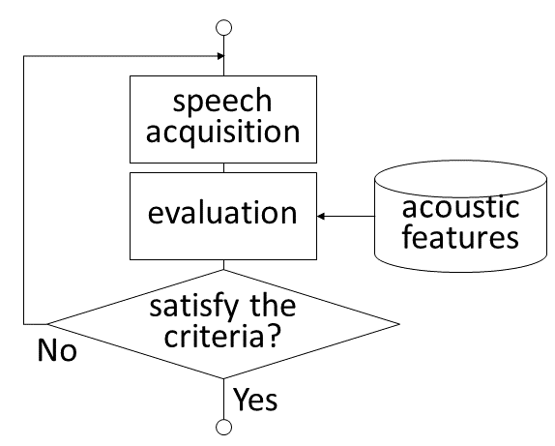

Fig. 4. Flowchart
Fig.4 shows the schematic overview of speech evaluation using acoustic features. An assumed strategy would be that to set criteria to satisfy in vocal training that is used to judge whether or not the user can finish training.

B. Generating virtual environment using acoustic features

As the preliminary experiment, we used augmented reality (AR) instead of virtual reality here where the system changed the size and the color of computer graphics that were superimposed in the real scene by reflecting the acoustic parameters of the user's speech [6] [7] . An example of user’s view in the virtual environment implemented is shown in Fig.6.

IV. Conclusion

We clarified that "jitter" for the vowel class, the dynamic range of power for the fricative class, and the length of silent period of time for the plosive class were feasible for visualizing the effect of vocal training by experiment.
Implementing the acoustic features in visualizing vocal quality in augmented reality and virtual reality demonstrated direct and intuitive feedback of the voice evaluation to the speaker.
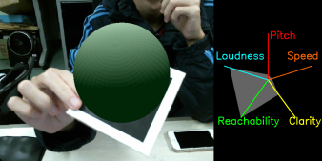
- /pi/
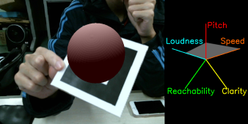
- /u/
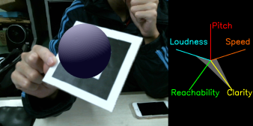
- /s/

Fig. 5 Speech visualization using AR
Future work includes developing the optimal algorithm that realizes vocal visualization in virtual environment through subjective tests.

Acknowledgement

This work was supported by “FY2016 MEXT Private University Research Branding Project”
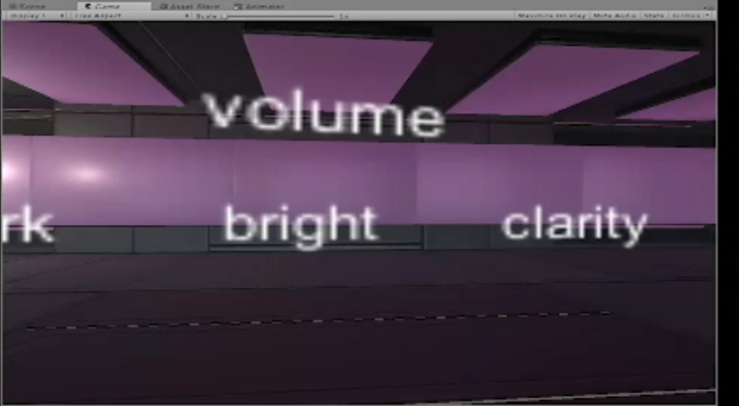
Fig. 6 An example of user's view in the virtual environment.

References

- Shogo Watanabe, Tsuyoshi Moriyama, Shinji Ozawa: "Phonetic and Intonation Enhancement of Speech for Japanese Hearing-Impaired Speakers", Proceedings of the IEEE Conference on Multimedia and Expo, pp.1429-1432, June, 2008.
- Kohei Furuya, Tsuyoshi Moriyama, Shinji Ozawa: "Generation of Speaker Mixture Voice using Spectrum Morphing", Proceedings of the IEEE Conference on Multimedia and Expo, pp.344-347, July, 2007.
- Tsuyoshi Moriyama, Shinji Ozawa: “Emotion Recognition and Synthesis System on Speech”, IEEE International Conference on Multimedia Computing and Systems (ICMCS'99), Vol.1, pp.840-844, June, 1999.
- Tsuyoshi Moriyama, Hideo Saito, Shinji Ozawa: “Evaluation of the relation between emotional concepts and emotional parameters on speech”, Proceedings of the IEEE International Conference on Acoustics, Speech, and Signal Processing (ICASSP'97), Vol.2, pp.1431-1434, April, 1997.
- Praat: doing phonetics by computer, http://www.fon.hum.uva.nl/praat/manual/Voice_2__Jitter.html, 2017/10/30.
- Van Krevelen, DWF and Poelman, Ronald, A survey of augmented reality technologies, applications and limitations, International Journal of Virtual Reality, Vol. 9, No.2, pp.1, 2010
- Open Source Augmented Reality SDK, http://www.fon.hum.uva.nl/praat/manual/Voice_2__Jitter.html, 2017/10/30.
- Oculus Rift, https://www.oculus.com/, 2017/10/30.
- Aung, Yee Mon and Al-Jumaily, Adel, Development of augmented reality rehabilitation games integrated with biofeedback for upper limb, Proceedings of the 5th International Conference on Rehabilitation Engineering & Assistive Technology, 2011.
- Schultheis, Maria T and Rizzo, Albert A , The application of virtual reality technology in rehabilitation, Rehabilitation psychology, Educational Publishing Foundation , Vol.46, No.3, 2001.

